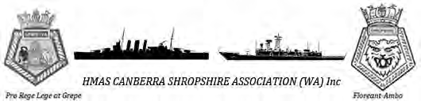
HMAS CANBERRA HMAS SHROPSHIRE Association WA Division
Minutes - Committee Meeting
20 July 2013
- Location
The monthly meeting of the HMAS CANBERRA HMAS SHROPSHIRE Association WA Division was held at the NAA Sub Section, 64 High St (cnr Pakenham/High Sts), Fremantle, WA.

The meeting was opened at 1100 (chaired by Sec) and members present were welcomed

- Members

There are 29 financial members, 3 more are expected to be announced shortly and a further 3 with incomplete paperwork that it is also hoped to have finalized in the near future

Welcome to New Members

Barry Chalk – June 2013
Damian Lamont – June 2013
Eric Radford – June 2013
Justin Grey – July 2013
Apologies
Accepted for the following personnel unable to attend the meeting:
Wade Green
Allister Daish
Justin Grey
Teresa Blackman
Don Yates
Blue Robinson
Ray Graham
- ‘Vale” – Lest We Forget
Bill Salter1920 to 2013, passed away 6 July from Stroke. 2nd last known WA survivor of HMAS Canberra1. Onm return to Aust, transferred to DEMS as a gunner. Cremated at Fremantle 13 July 2013. Assoc’n represented represented ceremonially by Pres and Sec.

M.I.D (Members In Distress)

Heather Parry – (Husband of Kim Parry – CanCom FFG02) undergoing intensive treatment in SA for cancer

Al Tait (QMG) (not Canberra) – Prostate Cancer – under treatment in WA
- 4. Meeting Agenda
- • Minutes from previous meeting presented
- Accepted: Barry Chalk
Seconded: Wayne Faulkner
Carry over of business from previous meetings arising from 15 June Minutes – outstanding items summarized by Sec for members present
- • Financial Status (monies in/monies out/balances).
  - Total Members: 28
  - Honorary Lifetime Members: 3 @ $50 donation
  - Ordinary members: 24 @ $50
  - Social members: 1 @ $30
  - Membership balance: $1380
  - One anonymous direct debit donation: $500
  - Association total balance: $1880
  - In Bank: $1630
  - In kitty: $250
  - Pending :
              - Moneys out $100 to Lee Webster (Donation Ride to Conquer Cancer, Not
              - yet delivered)
Pending 1 new Member Justin Grey (Awaiting bank statement to confirm funds in account.)

-  New Business
- Fund raising

- Marketing Coordinator – Jason Gordon
Fund raising is required to take pressure off members fees. It is also required to show authorities and businesses (e.g. DVA, Bank West, etc) that provide grants that we do not rely on them for handouts.

Jason has several examples and quotes to present to the Committee. However his computer is currently u/s and he cannot extract the information. Watch this space next month.
- Yarloop Pub/Vintage Car Show - Damian Lamont
Damian has had a preliminary conversation with the publican with regard to shop fronting the Assoc. at a Vintage car Show in Yarloop. A member (WF) present at the CM has been to the Yarloop event previously and it appears to be a very sociable event that would expose the Assoc to the public. Damian was to attend the CM and give the members more detail, however he is ‘off shore’ at present (FIFO). The Members felt it could be a good opportunity

- Bank West Community Grant $1000 - David Shine
The Bank releases 20 grants per month nationwide for community wellbeing. Paperwork to support our approach to the bank will emphasise the support we have for our WW11 veterans and the financial expenditure/drain on their families for the journey to the commissioning of Canberra 3 next year.

- Bunnings Sausage Sizzle - ideas/supporters/volunteers?
Wayne Faulkner will fact find on the driving forces required (insurance, logistics, supplies, etc) to carry out a fund raising event at a Bunnings store near you!

- Medal Holders – Plexiglasss pocket slide - David Shine
These plexiglass sleeves hold your medals trim against your jacket or shirt breast in a horizontal uniform height. It has supports that when you put the medal bar pin through, it allows the medals to hinge and hang outside the pocket. It does away with the destruction (pin holes) of your jacket or shirt and ensures that your gongs line up perfectly on the first time. See embedded examples.

I have a limited supply at $15 each. Your purchase will cover the purchase and mail cost and also put $5 into the Assoc bank. If you would like 1 or more, contact me and I will get it to you. shinedem@iinet.net.au or secretary@hmascanberra-shropshire.asn.au

- Constitutional Review –
By now you would have received a word copy of the Assoc. Constitution that will allow you to amend as you see fit. Dept of Commerce (WA Gov) kindly allows us 18mths to trial our original/inaugural version (4) and then fine tune it. It is now open to the members to do this, if you see a need. I must have any alterations/amendments back from you on or before 15th August to allow time to collate response and present it to the next Committee Meeting 17 Aug
- Annual Audit of Assoc’n Finances and Administrative Documentation –Vicki Graham, Chartered Accountant has been appointed to audit our books to ensure we are up and above board. It is a Dept. of Commerce stipulation that we do this annually to provide visibility that we are operating as a Incorporated Association. The result of this audit will be presented at the AGM prior to being made available to the DoC. The timing of this audit and stakeholders are noted in the attached Schedule of Events

- Annual Dinner (Potential date 23 Nov)
A sub committee has been formed to address the logistics involved in putting on an annual dinner. Anyone with ideas or who can help, please contact me or Wayne.Faulkner@DHL.com.

- Contact for FFG Assoc.
Who? Exist? No one knew at the meeting who can be contacted for information or if indeed an FFG Assoc actually exists. There may be a HMAS Adelaide and or a HMAS Darwin assoc being formed. If these rumours become truth, it is intend to invite them, if they wish, to march under FFG 02 banner or their own within the Canb-Shrop Assoc. as associates. More decisive action will be made when and if any further information comes to light. Currently there is no objection to others wishing to march with us. (We already do this ad hoc at a march on the day)

- NAA Ftle/Navy Club Ftle.
Currently the Assoc. is informally affiliated with NAA Fremantle and the Navy Club Fremantle. Both of these entities have been an enormous assistance to our Association during the past 18 months.

A Big Thanks is extended to the management and staff of of the NAA and the Navy Club for their help in the setup of our organization and the provision of a convenient and centralized HQ

- Future direction – National Body with a national newspaper.

The following is a summary of the discussion held on the subject
Intention:

CANBERRA-SHROPSHIRE Assoc. to operate as a National Body

Objective:

To provide one strong voice when required to meet the Assoc. objectives (1-5 below)

1. To bring together those men and woman who served in the ship bearing the name HMAS CANBERRA and those men who served in the ship bearing the name HMAS SHROPSHIRE.
2. To welcome and encourage participation in the Association by those men and women of the Royal Australian Navy who serve in any future ships bearing the name HMAS CANBERRA or HMAS SHROPSHIRE.
3. To foster and maintain friendships formed during service in peace and times of war, and to honour the memory of shipmates lost in action or since deceased.
4. To welcome and extend hospitality to Officers and Sailors of any ships bearing the name HMAS CANBERRA or HMAS SHROPSHIRE
5. To support members (and families) where possible who are in need in times of dire necessity.
How:

- Recognise that WA, Qld and ACT have vibrant Sub Divisions, that NSW and Vic Sub Divisions are approaching a moribund state and further that Tas and SA have recently become dormant.

- Individual State Sub Divisions (existing and future bodies) are to retain autonomy to ensure their existence based on state issues represented by the State Membership

- a National approach be taken via a National Body where common issues relating to all Sub Divisions (veterans, serving members and families) occur,

- Retain and follow the existing stated Objectives and the Association Motto (Two Ships- One Crew)

- WA Membership is opened to all who have difficulty in gaining membership in other States due to dormant or nonexistent sub Divisions i.e. NT, SA, Tas, NSW and Vic.

Action:

Lee Webster to investigate through the “Chamber Of Commerce Guidelines on The Setting Up of an Incorporation’, the legalities and formalities of forming a National Body. A draft Charter is to be drawn up and tabled at the next Committee Meeting

Proposed – Wayne Faulkner

Seconded – Barry Chalk

Motion Carried

- DVA Newsletter is on the website

9. DVA Workshop at Mandurah RSL.
Four personnel attended among the 80 others. NAA Ftle were also invited. The primary message was ‘Get your claims started and submit them, no matter how small/trivial it may appear today as tomorrow may be too late’.
DVA website gives access to many avenues for assistance. Also our Association DVA Advocate is <jeffwake@westnet.com.au> from the Fremantle Navy Club.
It is important to realize that these services are available to you or your next of kin, especially after you pass away.
Subjects covered by guest speakers
New DVA Initiatives – Veterans Access Network DVA has offices at HMAS Stirling, Army Museum Fremantle, and two new electronidc tools ‘ My Account” (gives access to your DVA records) and ‘eHealth’ (gives the person ownership and tracks your own health records)
Veteran Assistance contact links is embedded at the rear of this document
Act, Belong, Commit. This is a Council program designed to draw the veteran and serving members into community programs to give a person a life outside the services through community services (sport clubs, community clubs, variety sponsorship, etc). The local Councils also offer free training in such items as basic accountancy, computer skills upgrade to assist personnel in running club administration.
Veterans and Veterans Families Counseling Service (VVCS). This organization is a specialized, confidential service that provides nation-wide counseling and support to Australian veterans, peacekeepers and their families and ADF personnel (serving members) – ph 1800 011 046 or www.dva.gov.au/health/vvcs
Commonwealth Rehabilitation Service (CRS). An overview was given on the services available to assist members to get back on the road again, mentally and physically.
War Widows Alliance – consists of a group of services who are dedicated to help and provide cares to the spouse (male or female) and the children left behind when a veteran or serving member passes away.
Department of Human Services – a Govt. department that is dedicated to assist veterans and families with practical applications to those in financial difficulty or who are able to see difficulty approaching
Further DVA workshops are planned for North Beach (9 Sep), Joondalup (17 Sep), and Rockingham (tba). There will bbe morning, afternoon and evening session. More will be broadcast when known.

10. Museum catalogue and storage facilities
Our Curator, Wayne Faulkner has begun cataloging material and has been investigating avenues for displaying material at the Navy Club. Anyone who would like to have record kept of their memorabilia, contact the Sec via <secretary@hmascanberra-shropshire.assn.au and I will assist you.
11. August 9th Memorial Service
Applications and invitations to dignitaries have been dispatched. Approval to hold a ceremony has been granted.
The Service will commence at the State War Memorial, Kings Park at 1030 on the 9th August. Muster in front of the Eternal Flame at 1020. It will be followed by ‘tea and bickies (or better) ’ at the restaurant on completion. Hope to see you there.
12. Commissioning Ceremony planning.
Progress report by the Pres. Still no firm commitment by CNS as to a time/date. Canberra 3 is continuing to plan ahead and it appears it will be a good weekend.
It is planned for the Assoc. to dovetail in with the ships plans. Until we get a firm date, the Assoc. cannot speculate as we then run the risk of perpetrating unfounded rumours that may cost member money.
Meanwhile the Committee is looking at several venues/events that should provide time to catch up with shipmates and to also give the member freedom to do other things.
13. Letters of appreciation and thanks will be sent out to several veterans families who have donated memorabilia to the Association.
14. Name badges. The Committee has reviewed several badge providers and we are close to choosing a badge for each member. Watch this space next month.

6. Next meeting 17 August commencing at 1100
-   Meeting Closed 1340

David Shine
Secretary
HMAS Canberra-Shropshire Association WA Inc
secretary@hmascanberra-shropshire.asn.au
Mbl 0408 955 607
Veterans Assistance Links

Credit rating | www.moneysmart.gov.au | Credit report. How to? What to do? Changes? Default?
DVA Photographs | www.flickr.com/dvaaus | Trips & interest
Mental health strategy & tools to manage | www.at-ease.dva.gov.au | Strategy, PTSD Coach Australia, free from App Store or Google Play (‘On Track’, ‘Right Mix’).
Recently left ADF-mental health | www.dva.gov.au/obas.htm | On base advisory service
YouTube videos | www.youtube.com/DVAAus | Veteran experiences with mental health & recovery
eHealth records | www.ehealth.gov.au | Register for eHealth online
Asbestos exoposure | www.defence.gov/dpe/ohsc/Programs/Asbestos/default.htm | Defence Asbestos Exposure Evaluation Scheme
Tinnitus |  | DVA 133 254/1800 555 254
MyAccount | www.myaccount.dva.gov.au | On line claim forms, review or establish DVA claims
Entitlements & Services (MyAccount) | www.dva.gov.au/esa | Claims, Reassessments &Entitlements self assessment
myGov | www.myGov.au | Link with a range of gov. online services in 1 secure place, 1 user name & password
Veterans Health | www.dva.gov.au/vhw.htm | Participate in organized events & physical activity in your area
DVA fact sheets | (try) www. Factsheets.dva.gov.au | Email: factsheets@dva.gov.au
Benghazi war cemetery
Last Post Ceremony | www.awm.gov.au | AWM interest portal

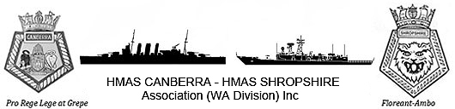
SCHEDULE OF EVENTS – 2013
Day | Date | Event | Comments
Saturday | 16 February | Association Meeting | Navy Club, Fremantle
Saturday | 16 March | Association Meeting | Navy Club, Fremantle
Saturday | 20 April | Association Meeting | Navy Club, Fremantle
Thursday | 25 April | ANZAC DAY | Dawn Service, Monument Hill, Fremantle  March, Perth  Navy Club, Fremantle
Saturday | 18 May | Association Meeting | Navy Club, Fremantle
Saturday | 15 June | Association Meeting | Navy Club, Fremantle
Saturday | 20 July | Association Meeting  Constitution Annual review - submissions to Sec for insert into Draft | Navy Club, Fremantle
Friday | 09 August | HMAS CANBERRA 1  Memorial Service | Kings Park Cenotaph, Perth
Saturday | 17 August | Association Meeting  Constitution annual review submissions closed. Items n to be inserted into draft copy  Annual Audit - stakeholders gather material and review | Navy Club, Fremantle
Saturday | 21 September | Association Meeting  Constitution Annual review – draft submitted draft to C’tee  Annual Audit - Submit items to Auditor for scrutiny | Navy Club, Fremantle
Saturday | 19 October | Annual General Meeting  Constitution Annual review proof submitted to AGM  Annual Audit proof submitted to AGM | Navy Club, Fremantle
Saturday | 16 November | Annual Dinner  Annual Audit submitted to Regulatory Authorities (Incorp). | TBA
Special event | 1st December | Birthdays  Ernie Rudland (1/12/23)  Jack Gallagher (2/5/25)  Bill Kynaston (29/12/25) | 90 yrs  88 Yrs  88 Yrs
Saturday | 21 December | Association Meeting | Navy Club, Fremantle
 | 2014 Jan-Apr | HMAS CANBERRA 3 Commissioning and National Reunion function | Garden Island, Sydney – dates TBA

It is intended to hold a national HMAS CANBERRA – HMAS SHROPSHIRE Association Reunion on the weekend of the Commissioning of HMAS CANBERRA 3 in Sydney. More information once it comes to hand.

Medal Holder - suits minatures (mess undress) and No. 1’s (ull ceremonial)

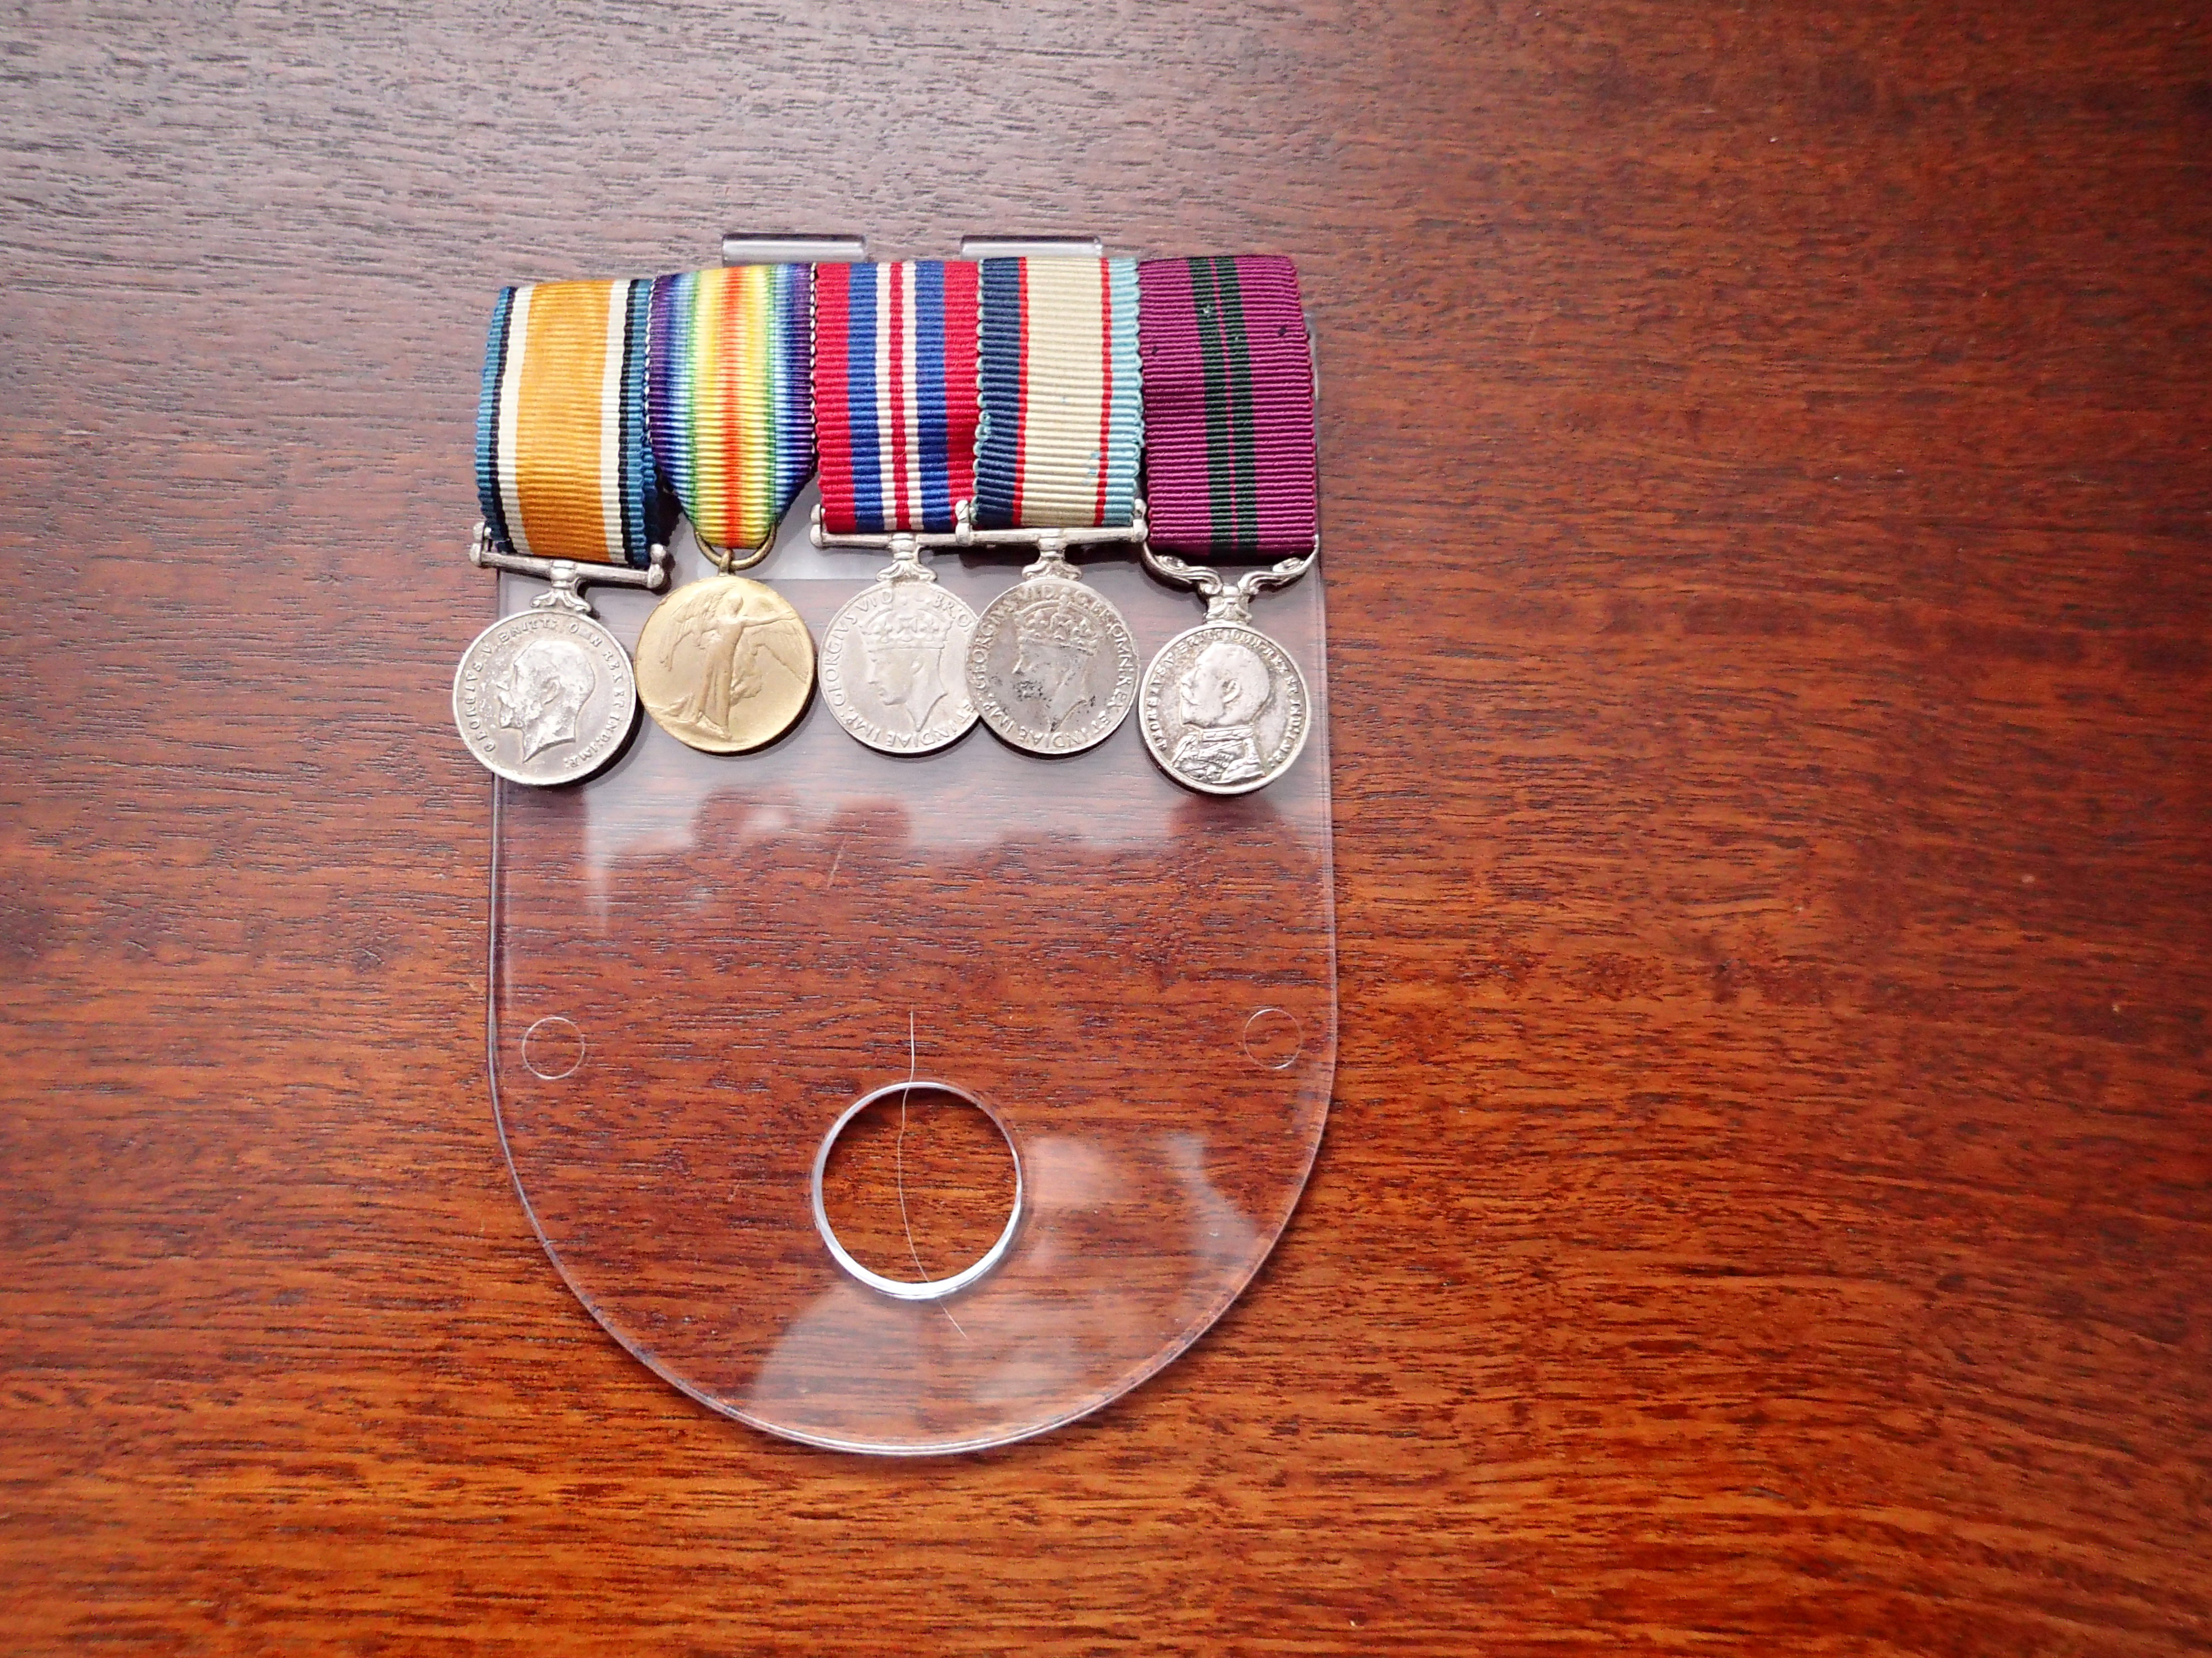

Reverse side showing pin holders

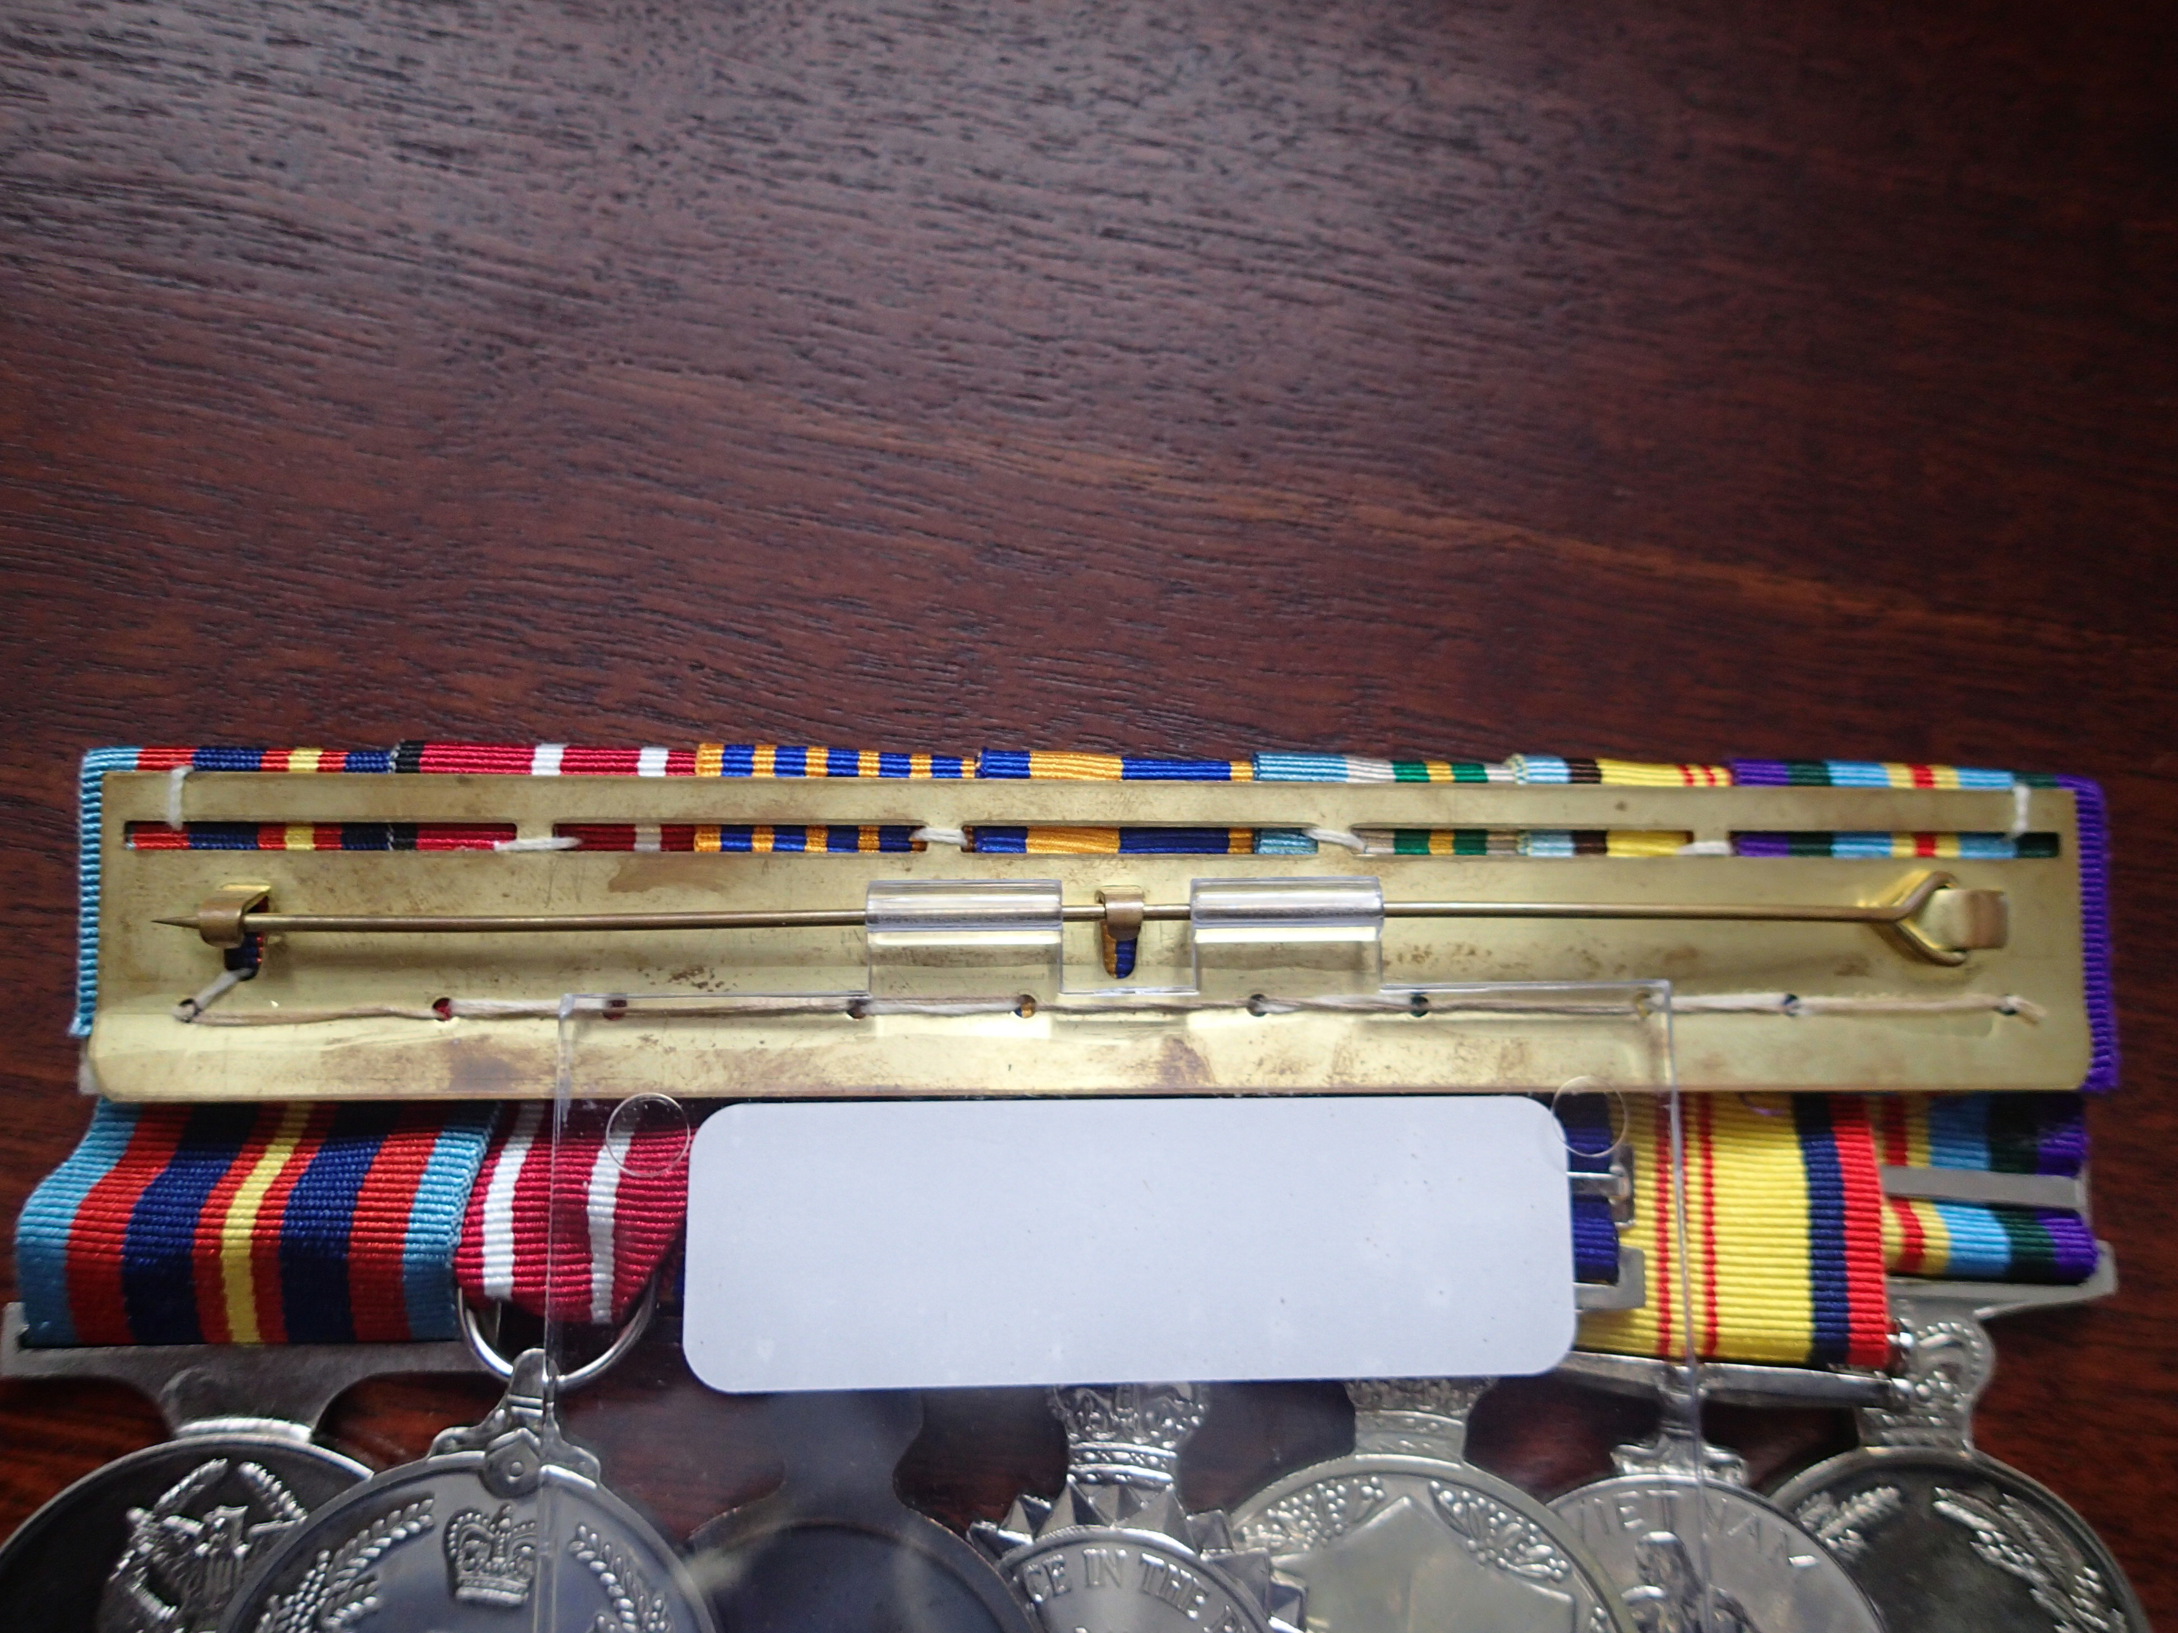

No. 1’s

